Name:______________________ Class: 6.___ (Write A, B, or C)
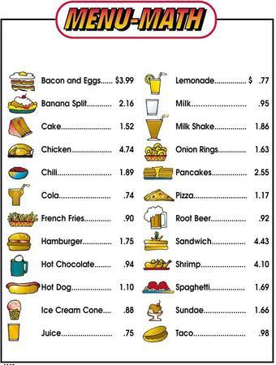

Finish the dialogue at a restaurant. Use the menu above and answer in complete sentences.

Waitress: Hello! What would you like?
Sally:
Waitress: Would you like anything else?
Sally:
Waitress: Would you like anything to drink?
Sally:
Waitress: Would you like to eat that here or To-Go?
Sally:
Waitress: Okay that will be, $_____.
Sally:
Waitress: Here you go, thank you!
Sally:
Waitress: Goodbye!
Sally:

